ASSIGNMENT - 6

COURSE | Cyber Security | ASSIGNMENT NO | 06
MODULE | Subnetting | ASSIGNMENT DATE | 08-12-25
STUDENT NAME | S Vyshnavi | SUBMISSION DATE | 14-12-25

Q1. Find the following
- Subnet the IP belongs to
- 1st Host in that Network
- Last Host in that Network
- Broadcast Address of that Network

- 192.168.224.29/19
- 172.6.248.156/21
- 209.28.34.76/25
- 10.17.0.106/14
Ans:

1. 192.168.224.29/19
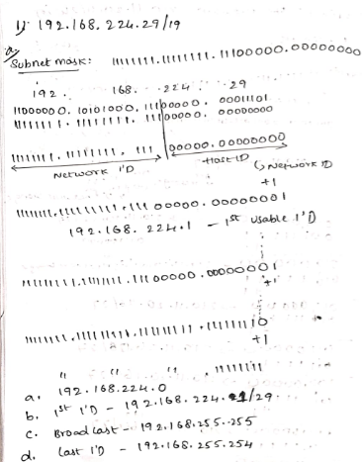

2. 172.6.248.156/21
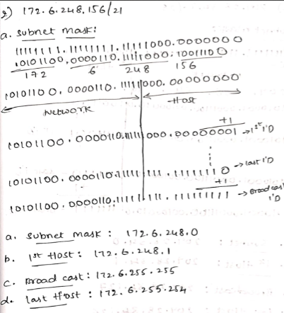

3. 209.28.34.76/25
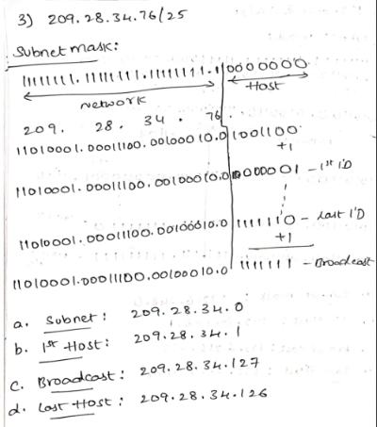

4. 10.17.0.106/14

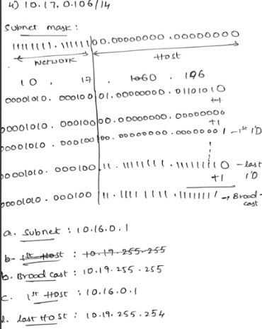

Q2. A new start-up upfront.com is establishing the network, you are given additional responsibility of helping the network administrator to subnet the network and assign the IP’s to their devices. You have been given the Network 192.168.20.0/24 Network, assign the subnet IP’s to each LAN.
Also, keep two subnets reserved for future expansion.

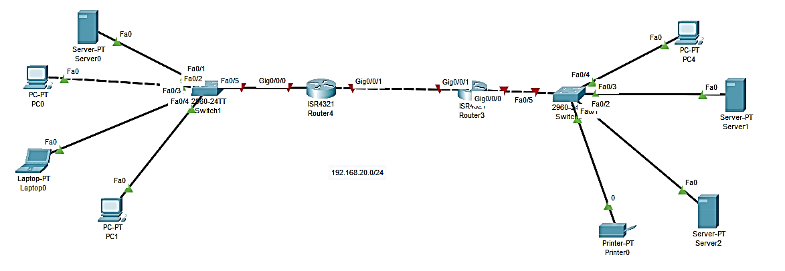

- Draw the Network and show the topology in Packet Tracer

screenshot of Topology
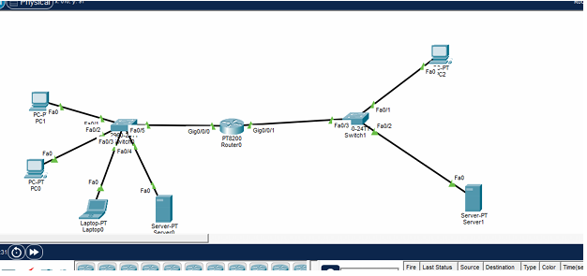

- Calculate the total subnet required, show the maths on how many networks required and host ID’s
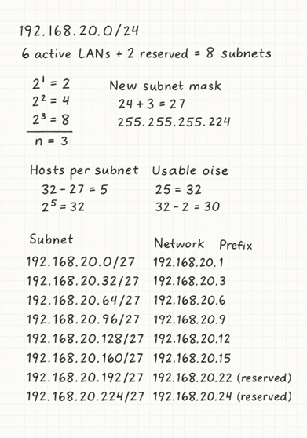

- Configure the IP’s on packet tracer

- IP OF PC0:
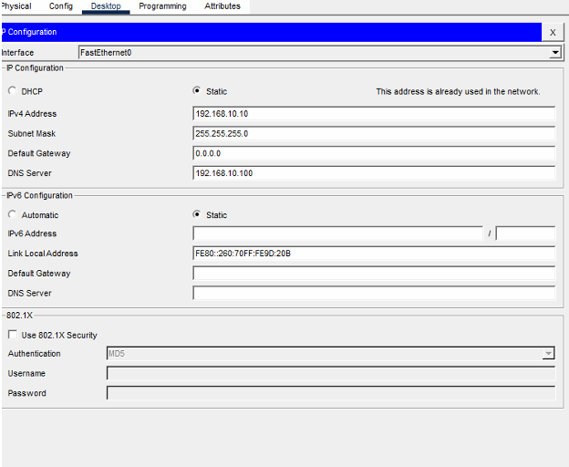

- IP OF PC1:
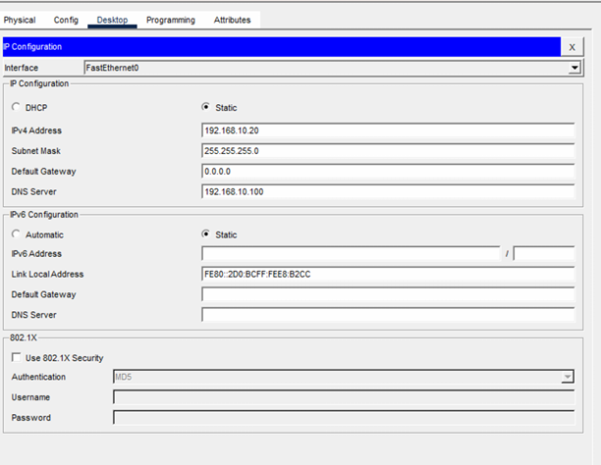

- IP OF laptop:
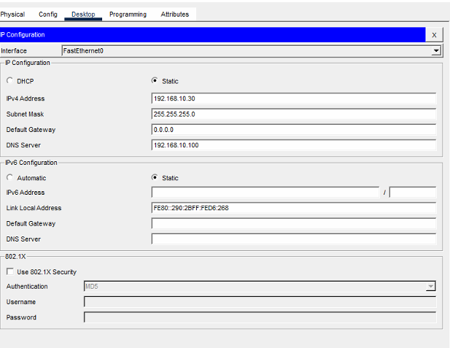

- IP OF SERVER0:

- IP OF PC2:
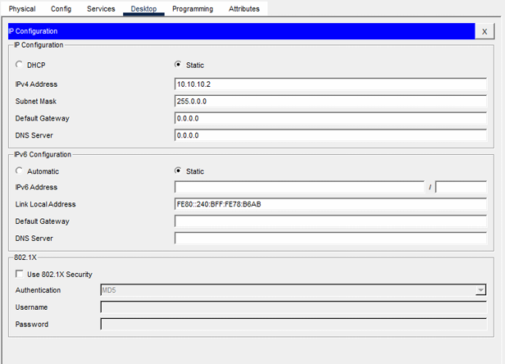

- IP OF SERVER1:
